FAQ: Hand Protection, NF11 and NF11X Safety Notification
How do I determine which gloves to quarantine?
NF11 and NF11X to be quarantined, were shipped prior to 1/1/2019.
There are also visual indicators
Outer case label before January 1, 2019 | Outer case label after January 1, 2019
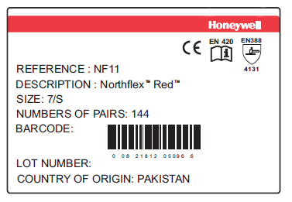 | 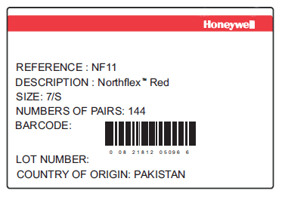
Case label is marked with CE information | Case label has CE information removed.
Inner, bundle pack insert card before January 1, 2019 | Inner, bundle pack insert card after January 1, 2019
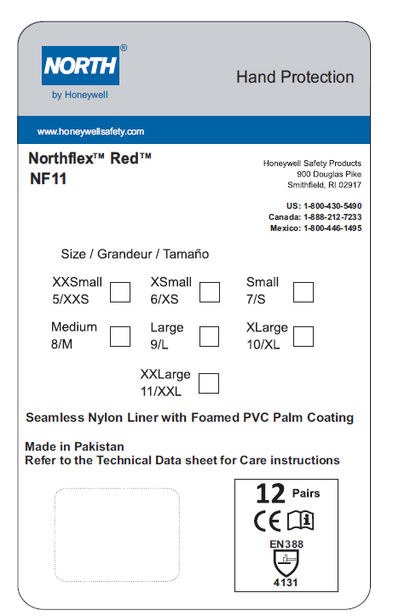 | 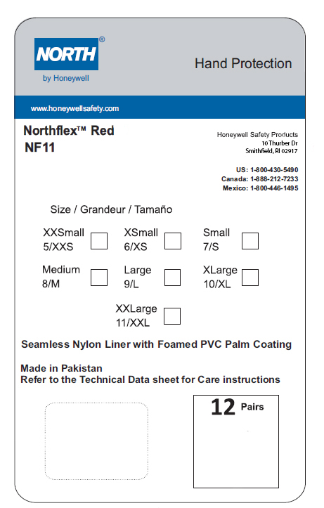
Inner pack, insert card is marked with CE information. | Inner pack, insert card has CE information removed.
Glove stamp before January 1, 2019 | Glove stamp after January 1, 2019
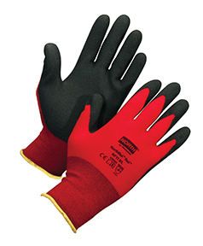 | 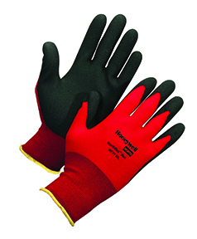
Glove stamp with North by Honeywell logo and CE information. | Glove stamp with Honeywell North logo and CE information removed
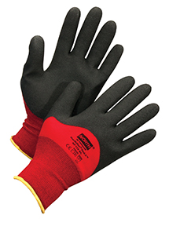 | 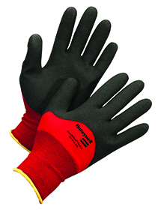

What should I do when I have identified the gloves for quarantine?
Log quantity by size, seal all product, and set aside. Mark wrapped product with a notice of “DO NOT USE”.
Can I return product to Honeywell?
No. There will be a secure site to return all product, for safe disposal.
How will I get credit for product?
You will be contacted by our contractor with more information on how to log and return product. At that time, a credit will be issued.
How will my customers be notified?
The Honeywell contractor will collect information to contact your customers, or will aid you in communication. Details will be released in the next week.
Is replacement product available, and has it been tested?
We do have product available, and additional product arriving. Product has been tested by a 3rd party lab, with no Azo dye reported.

